**Microprocessor System & Interfacing Lab**

**Project Report**



**“Line Following Robot using 8051 Microcontroller”**

**Fall 2016**

**Submitted By:**

**Waleed Niaz FA16-BEE-054**

**Supervisor:**

**“Engr. Zubair Khaliq”**

**Table of Contents**

**Introduction: 3**

**Project Aim: 3**

**Hardware: 4**

**Source Code: 5**

**List of Equipment: 6**

**Schematic Diagram: 7**

**Future Work: 8**

**Conclusion: 8**

# **Introduction:**

**Line follower robots were one of the earliest automatic guided robots. They can follow a line marked on a contrasting background, usually a black line on a white surface or a white line on a black surface. Usually, the line follower robot works on a closed loop feedback algorithm where the feedback from the line sensor is used by the controller for correcting the path of the robot. The sensors are usually LED/LDR, LED/Photodiode or LED/Phototransistor pairs and the controller is an electronic circuit which executes the desired feedback algorithm. Gear motors are used for driving the robotic wheels.**

**The line follower robot presented here is designed to follow a black line on a white background. It has a pair of sensors (LED / LDR) and works on a simple “align robot on the center of the line algorithm”. We are using the microcontroller just to demonstrate the technology. Also, this project serves as a platform for advanced line follower robots which works on complex algorithms. AT89S52 from Atmel is the microcontroller used here.**

# **Project Aim:**

**This project aims to implement the algorithm and control the movement of robot by proper tuning of the control parameters and thus achieve better performance.**

* **These robots can be used as automated equipment carriers in industries replacing traditional conveyer belts.**
* **These robots can also be used as**[**automatic cars**](https://www.elprocus.com/line-follower-robot-basics-controlling/)**running on roads with embedded magnets.**
* **These can also be used at homes for domestic purposes like floor cleaning etc.**
* **These can be used in public places like shopping malls, museums etc. to provide path guidance.**

# **Hardware:**

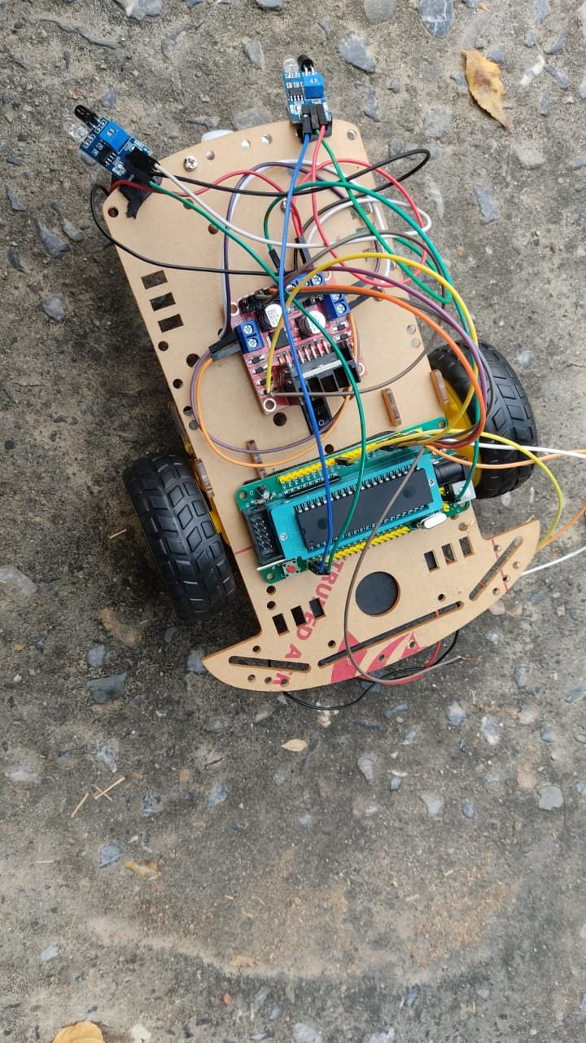

# 

# **Source Code:**

***ORG 000H***

***SETB P1.0***

***SETB P1.1***

***CLR P2.0***

***CLR P2.1***

***CLR P2.2***

***CLR P2.3***

***AGAIN:***

***JB P1.0,NEXT***

***JB P1.1,GO***

***CLR P2.0***

***CLR P2.1***

***CLR P2.2***

***CLR P2.3***

***SJMP AGAIN***

***GO:***

***CLR P2.0***

***CLR P2.1***

***CLR P2.2***

***SETB P2.3***

***CLR P2.3***

***SJMP AGAIN***

***NEXT:***

***JB P1.1,GO1***

***CLR P2.0***

***CLR P2.2***

***CLR P2.3***

***SETB P2.1***

***CLR P2.1***

***SJMP AGAIN***

***GO1:***

***CLR P2.0***

***SETB P2.1***

***CLR P2.2***

***SETB P2.3***

***SJMP AGAIN***

***RET***

***END***

# **List of Equipment:**

**The components used are as following:**

* **8051 Microcontroller**
* **Development Board for 8051 Microcontroller (preferred)**
* **10KΩ Resistors X 2**
* **10µF Capacitor**
* **11.0592MHz Crystal**
* **33pF Capacitors X 2**
* **Push Button**
* **Motor driver Module (L298N)**
* **Robot Chassis with Motors**
* **IR Sensors x 2**

# **Future Work:**

**The line follower developed is also sensing any type of obstacle in its way and can also control speed with the help of speed regulator. Further improvement can be done in the robot by using a greater number of IR sensors or an array or IR sensors.**

# **Conclusion:**

**In this project we have designed the “The Line Following Robot using Microcontroller 8051”. In this project we have used IR sensor module and the motion of robot direction depends on the sensors. We have drawn the black color path on light color surface with black color tape. When the two (2) sensors are on the line path, robot moves forward. If the left sensor moves away from the line, robot moves towards right. Similarly, if right sensor moves away from the path, robot moves towards left. When the robot moves out of the path, sensors check it automatically and adjust the robot. The line following robot is easy to make and use. This robot has many applications as it can be used in industries to carry products from one place to another, can also be used in self driving cars etc.**